Applied Intelligence https://doi.org/10.1007/s10489-023-04469-9


Traffic signal optimization control method based on adaptive weighted averaged double deep Q network

Youqing Chen¹ · Huizhen Zhang¹ · Minglei Liu¹ · Ming Ye¹ · Hui Xie¹ · Yubiao Pan¹

Accepted: 10 January 2023
© The Author(s), under exclusive licence to Springer Science+Business Media, LLC, part of Springer Nature 2023

Abstract
As a critical node and major bottleneck of the urban traffic networks, the control of traffic signals at road intersections has an essential impact on road traffic flow and congestion. Deep reinforcement learning algorithms have shown excellent control effects on traffic signal timing optimization. Still, the diversity of actual road control scenarios and real-time control requirements have put forward higher requirements on the adaptiveness of the algorithms. This paper proposes an Adaptive Weighted Averaged Double Deep Q Network (AWA-DDQN) based traffic signal optimal control method. Firstly, the formula is used to calculate the double estimator weight for updating the network model. Then, the mean value of the action evaluation is calculated by the network history parameters as the target value. Based on this, a certain number of adjacent action evaluation values are used to generate hyperparameters for weight calculation through the fully connected layer, and the number of action values for mean calculation is gradually reduced to enhance the stability of model training. Finally, simulation experiments were conducted using the traffic simulation software Vissim. The results show that the AWA-DDQN-based signal control method effectively reduces the average delay time, the average queue length and the average number of stops of vehicles compared with existing methods, and significantly improves traffic flow efficiency at intersections.
Keywords Reinforcement learning · Deep learning · Double deep Q network · Intelligent transportation · Traffic signal control

Introduction
As the world economy continues to grow, the number of cars in major cities is rising rapidly. As of March 2022, the
number of motor vehicles in China has reached 405 million, including 307 million automobiles. The high-speed growth of car ownership is attributed to rising per capita income and brings great convenience to daily travel, but the increasingly

severe traffic congestion keeps raising people’s travel costs.

 Huizhen Zhang zhanghz@hqu.edu.cn

Youqing Chen 20013083006@stu.hqu.edu.cn

Minglei Liu 20013083020@stu.hqu.edu.cn

Ming Ye 21014083093@stu.hqu.edu.cn

Hui Xie 21014083086@stu.hqu.edu.cn

Yubiao Pan panyubiao@hqu.edu.cn

1 College of Computer Science and Technology, Huaqiao University, Xiamen, 361024, Fujian, China
Urban road congestion has become a problem needed to be solved for traffic management departments. In addition to expanding new traffic roads, optimizing the management of the original infrastructure is also particularly important. As the critical node of the urban traffic network, how to improve the traffic throughput capacity of the intersection is a crucial issue in improving the road environment.
Traffic signals are used as the main means of traffic flow control at intersections. Periodic fixed timing is the mainstream method of signal control scheme, but the inability to adjust the signal control scheme adaptively by real-time traffic flow information is the obvious drawback of fixed timing [1]. Adaptive traffic signal control methods are dedicated to dynamically adjusting signal timing based on real-time traffic flow arrival characteristics and optimization objectives. Deep reinforcement learning, a new research hotspot in artificial intelligence, has shown great potential

in adaptive traffic signal timing optimization methods by using the fitting ability of deep neural networks and the decision-making advantage of reinforcement learning.
The current deep reinforcement learning algorithms for traffic signal control can be broadly classified into value function based algorithms and policy gradient based algorithms [2]. Due to the phase setting characteristics of road intersections determines that discrete actions are more suitable for modeling, value-based Q-learning algorithms in discrete action environments have more research results on optimal traffic signal control. When combined with neural networks, the value-based reinforcement learning algorithm’s main task is to extract the input state information through various networks and fit a more accurate action evaluation value to guide the signal to make the optimal phase switching action. And the Deep Q Network (DQN) [3] model combining deep learning and Q-learning algorithms has achieved significant optimization results in the experimental environment and has become the mainstream method for discrete action control of intelligent signals. The basic model of DQN applied to traffic signal control is shown in Fig. 1.
In practice applications, the DQN model uses a max function to select the action with the largest Q value in the evaluation network as the optimal action to accelerate the action evaluation value toward the optimization objective. And the model uses the same target network to select actions and evaluate target values, however, this operation tends to lead to overestimation of the evaluation [4]. Van
[5] proposed the Double Deep Q Network(DDQN) model based on the classical DQN, and the algorithm did not construct a new network model. Instead, it determines the objective function by decoupling the optimal action selection and the target Q value calculation on the original structure, which alleviates the problem of overestimation of DQN to some extent. In the training process of DDQN, instead of directly obtaining the action corresponding to the maximum Q value from the target Q network, the action with to the maximum evaluation value is defined in the evaluation network, and then the target Q value is calculated in the target network using that action. However, the Q value calculated by the target network during DDQN training must be less than or equal to the Q value attained by the original network, i.e., DDQN has the same estimation

Layer 1
Q-value network of reinforcement learning (Agent)
Convolution+Activation
Convolution+Activation
……
……
……
……
……

Layer M
Convolution+Activation
Layer N-1
fully connected+Activation
Layer 2

……
Layer N
fully connected+Activation

Output layer

……
Delay / Switch to target phase
……
……

data collection:
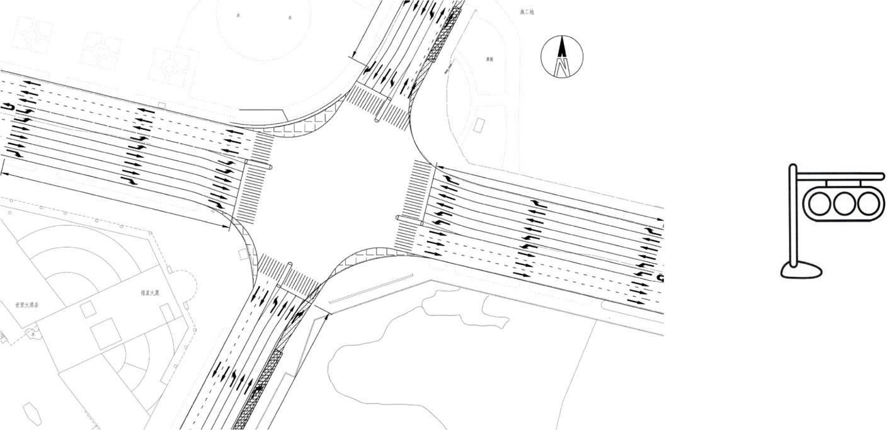
Traffic Status(S)
Reward evaluation(R)
Fengze-Tian’an Intersection
Light color command of traffic lights

Signal control intersection (Environment)
Fig. 1 Basic model of DQN applied to traffic signal control

error for the calculation of action values before the network model converges [6]. Although such deviation values are small, they will also have an enormous impact on the learned strategies during the training of the model.
In order to improve the accuracy of value-based deep reinforcement learning algorithms for action evaluation values, related scholars have proposed different solutions in terms of how the target value is computed. The Averaged DQN algorithm [7] estimates the value of the current state by a number of previously learned Q-value functions and calculates the final target value by finding the mean value, thereby improving the training stability by reducing the variance of the target approximation error. Weighted Double Q-learning [8] evaluates the current state value using two independent estimators, one estimator determines the action that rewards the maximum value and the other provides an estimate of the state value. The inaccuracy of the original single and double estimators for evaluating the target value is mitigated by weighting the double estimators. The Weighted Averaged Double Deep Q Network model
[9] combines the concepts of Averaged DQN and Weighted Double Q-learning by integrating double estimators with weights into a Deep Double Q Network to generate target values by calculating the mean of previously learned action estimates. However, the hyperparameters of the algorithm’s weight calculation are set as constants, and the network parameters for optimal values in different application scenarios need to be tried and selected carefully, which does not have the universality of the algorithm for wide application.
Based on the above status quo, to tackle the problem of estimation bias of DQN and its improved model for action values in traffic signal control environment, and in order to improve the self-adaptability of the model in different traffic scenes, this paper proposes a traffic signal optimization control method based on Adaptive Weighted Averaged Double Deep Q Network (AWA- DDQN). The method obtains real-time traffic flow information on the road through discrete traffic state encoding, and uses the number of queued vehicles with fixed allocation times as a baseline when setting up the reward so that it adaptively adjusts the relevant parameters according to the characteristics of the application scenes in the process of continuous interaction with the environment, which in turn determines the weight assignment of the evaluation network and the target network when the model parameters are updated, and the number of adjacent parameters used to evaluate the average value of the actions. The results of the Vissim simulation experiments show that the AWA-DDQN-based traffic signal optimization control method can effectively improve the efficiency of road intersections.
The remainder of this paper is organized as follows. Section 2 introduces the related work on traffic signal con-trol using deep reinforcement learning methods, Section 3 details the setting of states, actions, and rewards in a rein-forcement learning environment from the problem defini-tion, Section 4 details the model structure and algorithm flow proposed in this paper, Section 5 conducts a compari-son experiment using the traffic simulation tool Vissim and analyzes the experimental results, Section 6 concludes this paper and gives an outlook on future work.

Related work
In a reinforcement learning based traffic signal control environment, the model aims to reduce overall traffic delays [10]. Through defining the traffic light at an intersection in a road as an agent and the external environment as traffic flow information in each direction into the lane, the agent obtains information about the environment through multidimensional real-time data and then selects the action to perform, thus obtaining reward feedback for model training. The reinforcement learning algorithm perceives the environmental state significantly better with neural networks [11]. The deep reinforcement learning model uses discrete traffic state encoding to obtain time-varying traffic flow information on the incoming lanes in a traffic signal control environment, allowing the agent to use finer-grained perceptual units to obtain real-time data about the road and to achieve an optimal mapping of states to actions through continuous interaction with the environment.
Since Li [12] et al. first used a deep neural network model to achieve single intersection traffic signal optimization in 2016, many new improvements have been proposed by specialists and scholars for value-based reinforcement learning algorithms applied to traffic signal scenarios. Wei
[13] et al. introduced the phase state information of a single intersection at the current moment while the agent obtained the road traffic flow information. The experimental results showed the superiority of the improved model in the simulation of traffic flow data at different time periods, but the experiments were only compared in a simple two-phase single intersection environment. Xu [14] proposed Deep Recurrent Q Network (DRQN) algorithm by combining DQN with Long short-term memory (LSTM). The experimental results showed that fitting the Q-value function through the LTSM network structure is an effective way to reduce the average delay of vehicles, but the state representation of discrete values, such as the number of vehicles and the average speed, cannot accurately describe the traffic environment. Zang [15] used the concept of

value-based meta-reinforcement learning to improve the training speed of the model applied to different scenarios but did not improve the optimization efficiency of the model from the structure of the algorithm. DDQN effectively reduces the overestimation problem of the DQN algorithm and experimentally demonstrates that it is more suitable for traffic flow control scenarios with dynamic changes but suffers from the shortage of model instability [16–18]. Han [19] fused the features of DDQN and Dueling-DQN [20] models to construct a Double Dueling Deep Q Network (D3QN) model to enhance the stability in the traffic signal control environment, but the simulation experiments did not perform sufficiently complete ablation experiments to show the improvement effect of the algorithm. Long [21] applied D3QN to a transit priority traffic scenario by considering multiple conflicting transit priority requests and traffic signal phase switching rules, and experiments showed that D3QN reduces the delay time and late probability of buses. But the existing techniques are temporarily unable to obtain parameters such as car passenger occupancy as required by the reward function. Based on the D3QN model, Liu [22] updated the priority of sequence samples in the experience replay buffer to further improve the utilization efficiency of training data. However, the improved algorithm based on D3QN has higher requirements for data and application environment, which leads to the difficulty of training the network model. Yoon [23] introduced Graph Neural Network (GNN) into the DQN model, and the algorithm feeds the states composed by the intersection spatial structure into GNN for training. The algorithm improves the adaptability to unexplored states, however, the experiments are performed only in artificially assumed traffic environments. Wang
[24] proposed a deep reinforcement learning framework incorporating traffic state prediction by building the deep neural network to predict information about the current state, the action, and the state at the next moment. Experiments were conducted to train the prediction network and deep Q network with the trajectory data of license plate recognition in Suzhou, China. The experimental results showed that the reinforcement learning algorithm combined with traffic state prediction significantly outperforms the traditional adaptive signal control algorithm. However, the diversity and uncertainty of real traffic scenarios require a huge amount of traffic flow data to train the prediction network, and the experiments only compared the early adaptive traffic signal control algorithms. Zhu [25] designed a model of broad learning to fuse different types of data to mine valuable information from vehicle and pedestrian states to assist in traffic signal decision-making. The experimental results showed that the proposed adaptive signal control algorithm has significant improvement in queue length and average delay, but the simulation time
of the experiment was only 300 seconds, which made it difficult to prove the optimization performance of the algorithm in a long-time control environment. Zhao [26] proposed a deep reinforcement learning signal control algorithm based on traffic intensity and phase duration awareness, which defines the traffic intensity of the intersection by traffic flow, thus setting up the reward and state of the algorithm to improve the accuracy of modeling. The algorithm adapts to different traffic scenarios by fine-tuning the phase duration, but the state input of the reinforcement learning agents focuses only on the traffic intensity of the intersection, and the discrete state description ignores essential information such as the speed and location of the vehicle. Shabestary [27] et al. defined the high-dimensional state definition of the signal light agent similar to the image in detail and refined the effect of vehicle delays on the reward function based on the state of the signal. The experiments tested the impact of different traffic factors on the optimization effect of the algorithm based on the DQN algorithm. Also, they compared the performance of tabular Q learning and DQN to demonstrate the optimization effect of deep reinforcement learning on intelligent traffic signals. However, the model used by the algorithm is only DQN, and the comparison of the optimization effect of the value-based deep reinforcement learning algorithm for different environments is missing.
In addition, several recent works have been carried out on traffic signal control from deep reinforcement learning algorithms based on policy gradient. Zhang
[28] proposed a cooperative multi-agent actor–critic deep reinforcement learning approach with value decomposition based on edge computing architecture, which decomposes the global learning tasks into local actor-critic sub-problems. The algorithm was deployed on the cloud side in the edge computing architecture to accelerate training, and simulation results showed that the traffic control scheme effectively reduces vehicle delays and queue lengths in the application scenario. Wu [29] et al. introduced the concept of Nash equilibrium in game theory into the A3C (Asynchronous Advantage Actor-critic) algorithm, and the experimental results showed that the proposed Nash-A3C (Nash Asynchronous Advantage Actor- Critic) algorithm has a significant optimization effect in reducing the average delay time in the experimental environment. However, the algorithm relies on IoT sensor devices and introduces concepts such as fog computing and edge computing, which largely enhance the difficulty of implementing the algorithm by implementing distributed computing in various ways. Ma
[30] et al. mined short-term traffic condition information at intersections as time-series images. The model they proposed could sense current and past traffic conditions separately for signal action decisions, and learn the dynamic relationship between past and current states. The algorithm

is modeled using an actor-critic reinforcement learning framework, and experimental results demonstrated that the algorithm optimizes the queue length and average delay at intersections. However, the experimental traffic flow data were set through artificial settings, and simulation experiments with real environment datasets are lacking.
Existing models based on deep reinforcement learning applied to single-point signal control have matured and can show significant optimization effects in the experimental simulation environment. Numerous network models have improved based on DQN, such as DDQN, Dueling-DQN, D3QN and other algorithms. These methods improve the optimization effect of DQN applied to signal light intelligent control by adding network structure and other methods, and the innovation point of the algorithm is the improvement of the network model. However, in the actual traffic environment, the diversity of road network control scenarios poses new requirements for the stability and effectiveness of the model. How to construct an effective signal control model for the experimental environment while combining the actual road characteristics with adaptive parameter design is a key problem that needs to be further addressed when deep reinforcement learning is applied to signal intelligent control.
To address the above problems, this paper constructs a single intersection signal model with fixed phase order based on DDQN, integrates the double-Q estimator with weights into the double Q network, and calculates the target value by the mean value of action estimates learned during training, while gradually reducing the number of mean action Q values for performing network parameter updates. The concept of mean value is used to balance the shortcomings of DQN and DDQN and improve agents’ decision-making accuracy. In addition, the algorithm uses discrete traffic state encoding to obtain information such as the location and speed of vehicles entering the lane, and sets reward function based on the global average speed and the road characteristics of the number of queued vehicles in different application scenarios to establish the single-signal optimal control model based on the Adaptive Weighted Averaged Double Deep Q Network.

System model
In the reinforcement learning-based traffic signal control
from predefined set of actions. Then, the environment switches to the new state s_{t+1} at time t +1 based on the previous action; At the same time, the agent will receive a return r_{t+1} from the change in the state of the environment. Through the continuous interaction between the agent and the external environment, the agent will gradually master how to take actions with the highest expected return in a given state. The process of learning by the signal light agents can be abstracted as a Markovian decision process, represented by a five-tuple: M =< S, A, P, R, γ >, where.
- S represents the set of states of the external envi-ronment, including all possible external environments observed by the agent.
- A represents the set of actions of an agent, which is
constructed by predefining all the actions that the agent can perform in the current environment.
- P represents the state transfer probability, and Pª _{r}
ss
represents the probability that the external environment is transferred to state s^{r} under state s by the action a.
- R is the reward function, and Rª denotes the reward
s
return that the external environment can obtain under the action a in state s.
- γ is a discount factor, which can be used to control
the impact of the immediate return in the future on the current reward when calculating the cumulative return in the current state.
In the reinforcement learning algorithm, the process of interaction between the agent and the environment is shown in Fig. 2:
A reinforcement learning algorithm uses the agent to continuously adapt its strategy according to the state changing of the environment and the feedback given by action, with the ultimate goal of finding the optimal strategy to cope with various states. This makes state, action, and reward the three main elements of algorithm construction. In the traffic signal control scenario, the road vehicle status is the most fundamental basis for signal control, so how to quickly and accurately identify the road vehicle status and transmit messages of what kind of action is effective for the max reward to the agent efficiently is the fundamental technical problem to be solved. The strategy of taking

environment, the signal in the road network combined with the optimal intelligent control algorithm is defined as the Agent, and the dynamically changing traffic flow on each approach lane of the intersection is defined as the Environment. In the process of interaction with the environment at the moment t , the agent, through the current state of the environment s_{t} choosing the action a_{t} execution
state
s_{t}
Agent
Environment
reward
r_{t}
rt+1

st+1

Fig. 2 Reinforcement learning framework

action
a_{t}

actions using the state and the reward definition of state switching by the agent directly affects the reliability of the model decisions. In order to utilize a more efficient training approach to guide the agent in decision making, these three key elements need to be set up first in the framework of reinforcement learning models for traffic signal control scenarios.

State

In the definition of traditional reinforcement learning applied to traffic states, the vehicle queue length or the overall traffic flow in each direction is generally chosen as the state. These scalar parameters can only provide a rough picture of the traffic state in a single aspect, which does not allow the agent to perceive the actual situation in the outside world in a detailed way [31]. Due to the simple table or linear function used in traditional reinforcement learning to guide the execution of actions, the algorithm suffers from a small state space and weak data processing capabilities. The curse of dimensionality of traditional reinforcement learning refers to the exponential growth of the state space of the environment with the increase in the number of system features. As research on deep neural networks has matured, deep reinforcement learning uses neural networks to automatically extract abstract features from data. Therefore, the agent is able to build value networks based on convolutional neural networks and fully connected layers for reinforcement learning applied to traffic signal control tasks and thus solve the value function. Intelligent control of traffic signals based on deep reinforcement learning uses vehicle speed and acceleration speed as well as signal phase information as input to the state, and even more directly uses pictures from cameras as input to the agent. Although it has become easier to obtain more accurate traffic flow information as the
performance of hardware devices continues to improve, intelligent signals require algorithms with high immediacy in time-varying traffic flows. Similar image data input with road greenery, vehicle color, and other factors not related to signal control requires deep learning models to perform more layers of learning and data dimensionality reduction, which is bound to significantly increase the processing time for decision making.
In order to obtain more comprehensive traffic flow state information, this paper adopts the mainstream Discrete Traffic State Encoding (DTSE) [32] method to transform the real-time traffic state of intersection entry lanes into same-specification cells, and use them as the state input of the model. Using DTSE as the input to the model can accurately reflect the real-time position and speed information of the vehicles, while the description can be used to predict the subsequent traffic state according to the travel characteristics of the traffic flow. Compared to traditional methods that use tabular-type parameters to represent information such as vehicle queue length and traffic flow, DTSE is able to extract the most effective information from the image data, ensuring the accuracy of environment portrayal while substantially reducing the cost of data processing, enabling intelligent signals to make effective decisions in a very short period [33].
The DTSE is obtained as shown in Fig. 3 by dividing each entry lane into cells at a fixed interval length within a certain distance from the front of the parking line. The length of the cells does not exceed the sum of the minimum car length and the parking spacing to ensure that only one car can be accommodated in a single cell, thus using the location of the body to determine whether there is a vehicle in each cell, and then expressed as an integer value of 0 or 1 as the location matrix of the vehicle. Similarly, a velocity matrix of the same scale as the vehicle position matrix is constructed based on the vehicle velocity on the road. The











Fig. 3 Discrete traffic state encoding schematic diagram
0
1

0

1 0 0
0 0 0
0 1 0
1 0 0
1
1
0
0
0
0
1
0

Algorithm State Input
0
1 1
1
0

vehicle position matrix
Stacking
0
32

0
0
25
0
0
25
0 0 12 0 0

20 0 0 0 0
0 0 15 0 0

0 0 0 3 0

vehicle velocity matrix
Real time traffic flow condition of approach Lane
Discrete Traffic State Encoding
Driving direction

value of the velocity matrix is expressed as the real-time velocity of the vehicle. By stacking the real-time position and velocity matrix information on the road to achieving an image-like detailed description, which is used as the input of the deep reinforcement learning model, the traffic flow information into the lane is effectively portrayed and helps to dig deeper into internal features.

Action

By observing the current traffic state, the traffic signal agent selects the best action from the action set according to certain rules, and the environment changes the phase of the current signal under the action performed, thus realizing the control of signal in different phases. Existing movement switching methods have both flexible phase sequences and fixed phase sequences. The flexible phase switching method speeds up the traffic evacuation in the congested direction to a certain extent, thus maximizing the road capacity of the intersection. However, overly flexible switching ignores the equity characteristics of traditional signal control methods. While intelligent signal control algorithms aim to reduce the overall global delay, they must not ignore the right of traffic flow in the direction of less traffic. The flexible phase sequence control method is likely to cause long waiting times for idle direction traffic in the intersection scenario where the traffic flow is more uneven. At the same time, in the classic signal fixed phase sequence of the application has matured, the majority of drivers are used to the cyclic phase sequence of driving scenarios, when the traffic signal sequence of change and years of driving habits conflict, it is easy to cause dangerous driving behavior. In order to avoid the behaviors mentioned above and be more in line with the real driving conditions and to ensure the fairness and rationality of intersection right-of-way distribution, the change of signal phases should be periodic, i.e., avoid irregular switching between different phases [34].
In this paper, in the control of phase switching of the traffic signal, the action set is defined in the phase order of the original signalized intersection in Fig. 1, and the signal phase is defined as the set such as, Phase={NslSrEr, NrSslWr, WsEs, NrSrWlrElr}, and the specific settings are shown in Fig. 4. The phases are transformed in
the order of NslSrEr→NrSslWr→WsEs→NrSrWlrElr: NslSrEr indicates that vehicles are allowed to go straight and turn left from north to south, right turn from south to north and right turn from east to west; NrSslWr indicates that vehicles are allowed to turn right from north to south, straight and left turn from south to north and right turn from west to east; WsEs indicates that vehicles are allowed to vehicles to turn right; WsEs indicates that the west to east direction allows vehicles to go straight, the east to west direction allows vehicles to go straight; NrSrWlrElr indicates that the north to south direction allows vehicles to turn right, the south to north direction allows vehicles to turn right, the west to east direction allows vehicles to turn left and right, the east to west direction allows vehicles to turn left and right.
The set of actions of the agent for traffic signal control is defined as A={0,1}. At any moment t of interaction with the environment, the traffic flow state of the intersection is s_{t} . The agent selects the optimal action a_{t} eA according to the current state. When a_{t} =0, the signal keeps the current phase unchanged; when a_{t} =1, the signal switches to the next phase of the current phase in the phase sequence. The
agent takes action at a spacing of simulation step, and to ensure the fairness of signal distribution in each direction. The shortest phase duration is defined as green_{min}, and the longest phase duration is green_{max}. At the same time, when phase switching occurs, a certain duration of yellow light time needs to be set between green light switching and red light switching to ensure traffic safety [35]. The green light time remaining from the phase switching time is counted as the duration of the phase. Based on the above phase sequence and action set, the agent is ready for cooperative scheduling with traffic signal.

Reward

The reward received by an agent from the change in the traffic environment after executing an action is an evaluation of the signal control decision and will impact the next signal control decision. In the reinforcement learning-based traffic signal control, the ability of an agent to learn the correct coordination strategy is closely related to the definition of the reward function [36, 37]. Therefore, many types









Fig. 4 Intersection phase diagram

First Phase(NslSrEr) Second Phase(NrSslWr) Third Phase(WsEs) Fourth Phase(NrSrWlrElr)

of reward setting methods have been proposed for traffic signal control scenarios, such as based on traffic flow changes, changes in vehicle delays at intersections, etc. [38]. Some of these factors are used to measure the immediate effect following a movement, while others measure the cumulative effect over time. Multiple aspects often reflect the evaluation of traffic conditions, and considering only one aspect of the metrics may not achieve the desired results. While choosing an appropriate reward function depends on the goal of traffic control [39], and an efficient signal control strategy should capture the global vehicle travel conditions and keep the vehicle queue length within a reasonable range. In the research setting of this paper, the reward function is defined as reward_{total} and is shown in (1).
reward_{total} = k₁ × reward₁ + k₂ × reward₂
,⎨ 1 current pre
reward = v v
of the samples. The AWA-DDQN model-based reward setting method is constructed by the above parameter setting method to prevent overly adventurous parameter updates from introducing the algorithm into an unstable dilemma.

Algorithm design

Overview of W-DDQN and WA-DDQN
The DQN makes use of the subsequent state-action value function when updating using the target value. Such a practice of using an estimate to update the same type of valuation is called bootstrapping [41]. The maximum operation taken by DQN in calculating the objective function value y^{DQN} is a common method of estimating the value function, the loss function of the DQN algorithm is shown in (2).

s.t .
l = ratio × Queuing veh_{fixed}
, reward₂ = l — queueV ehicles
(1)
y^{DQN} = r + γ max_{a}r Qˆ (s^{r}, a^{r}; θ —)

(2)

The reward function is divided into two parts: the first part reward₁ is the global speed difference between t and t + 1. v_{current} is the global average speed of the current moment. v_{pre} is the global average speed of the previous time step, using the global speed to reflect the traffic flow crowded grade of the road. The second part reward₂ is obtained by calculating the difference between the average number of queue vehicles under the original fixed timing scheme Queuing veh_{fixed} with ratio e [0,1] and the difference with the number of queueV ehicles of the road in real-time under the control of the model. The average number of queuing vehicles under the fixed timing scheme is still much higher than the number of queuing vehicles under the adaptive signal control scheme. It is not easy to reflect the reward and punishment by directly comparing Queuing veh_{fixed} with the queuing vehicles under the intelligent algorithm. Therefore, a certain proportion of Queuing veh_{fixed} needs to be reduced in order to be used as a baseline for queuing vehicles so that the intelligent control method can be used to compare the number of vehicles in the queue with the fixed allocation time for judging the action. A reasonable baseline setting emphasizes the positive and negative nature of the rewards and reduces the variance in the model training process, thus enhancing the stability of the learning process [40].
Based on the above two parts of the traffic elements, the baseline of the reward function is set according to the traffic
Loss_{DQN} = (y^{DQN} — Q(s, a; θ ))2
Where θ is the parameter of the evaluation network and θ — is the parameter of the target network. Since the process of selecting an action based on the state of the next time step in the DQN uses the same network model parameters as predicting the Q value for the next time step, such an operation can produce overestimated values for action evaluation, which can lead to overly optimistic estimates of the value function [42]. The overestimation of DQN for different action evaluation values is not balanced, and the more frequently the action is selected, the higher the degree of overestimation, which will eventually lead to the probability of the second-best action being selected higher than the possibility of the best action. In the traffic signal control scenario, misjudging the phase switching action that should be executed in the current state will not only lead to an increase in the overall vehicle delay but even have the possibility of bringing about traffic accidents [43].
To avoid the above situation, DDQN decouples action selection and state action estimation, and uses the two networks of the original structure of DQN to perform the evaluation of action values under s and s^{r}, respectively,
reducing the direct correlation between target value
calculation and action selection. The original DDQN loss function is shown in (3).
,⎨, y = r + γ Q(s , u; θ )
DDQN ˆ r —

flow state in different traffic environments, and different weights k₁ and k₂ are assigned to it. The assignment of weights requires that the overall reward value of each
u = arg max_{a}r (Q(s^{r}, a^{r}; θ ))
, Loss_{DDQN} = (y^{DDQN} — Q(s, a; θ ))
, ₂
(3)

time step is controlled within a certain range to ensure that the model updates the network parameters in small steps during the training process using the reward values
The temporal difference objective function y^{DDQN} of the DDQN consists of two parts: the first part is the immediate return r of the current time step, and the second

part is the γ times of the estimated Q value of the target network value in the next state s^{r} and the optimal action a^{r} evaluated by the evaluation network. The loss function is optimized by summing the above two parts with Q(s,a;θ ) as a way to update the parameters θ of the evaluation network. Although DDQN can effectively control the risk of overestimation, the lag that exists in the updating of the target network may produce an underestimation of the action estimates due to the fact that the model uses two independent value functions [44]. Although the possibility of underestimation or overestimation of both estimators in the same action is low, it can also affect the accuracy of the model for state estimation at the time of convergence to some extent. For this reason, the research work in the literature [9] proposed a Weighted Double Deep Q Network (W-DDQN) and a Weighted Averaged Double Deep Q
Network (WA-DDQN).

Weighted double deep Q network

The W-DDQN integrates the target value update method with weights into the DDQN. The model generates the temporal difference objective function by combining the algorithmic characteristics of the original DQN and DDQN in the loss function calculation, which effectively reduces the estimation bias of the model.
DDQN is built on the basis of the temporal difference algorithm Q-learning, which uses a bootstrapping approach, i.e., the Q-value of the current state s at t is estimated using
the value function of the state s^{r} at t +1. DDQN uses neural
networks to predict state-action Q values, and the goal of
model optimization is the objective function y^{DDQN} and the accuracy of the value computed by evaluation network under the current state-action, so the update of the network parameters uses the loss function composed of y^{DDQN} and Q(s,a;θ ) for the backward propagation of parameters. Thus,
the model innovation proposed by W-DDQN on DDQN

values of a∗ and a_{L} and then the absolute values are derived by the difference, and the weights β are generated by calculating the absolute values with the constants. The algorithm assigns a weight of β to the evaluation network and a weight of (1-β) to the target network value. The calculation of y^{W—DDQN} is performed by the above-assigned weights, and then the final update of the network parameters is performed by the loss function.
Since both DQN and DDQN have the problem of estimation bias, the degree of inaccurate estimation caused by both is likewise not balanced. By dynamically adjusting the update weights of each DQN and DDQN, the W-DDQN improvement model seeks the most accurate evaluation effect that can be achieved by combining the characteristics of both models and improving the general applicability of the model for different scenarios.

Weighted averaged double deep Q network

The WA-DDQN is an improved scheme based on W-DDQN. The model constructs the objective function by the weighted sum of the evaluation network and target network calculation, and at the same time, introduces certain adjacent training steps for averaging the evaluation state-action values. The model uses the Q-value estimates of the double network parameter evaluations recorded in several previous time steps for the averaging calculation, thus reducing the negative impact of the unstable training process and ensuring a more stable training process for the model.
The WA-DDQN-based temporal difference objective function is shown in (5).
y^{WA—DDQN} = r + γ [β × 1 Q(s^{r}, a∗; θ )
K
k
Σ
K
k=1
+(1 — β) × 1 Σ Qˆ (s^{r}, a∗; θ —)]
,,
K
k
K

k=1

is an improvement in the composition of the temporal difference objective.
The W-DDQN-based temporal difference objective function is shown in (4).

s.t .
β = |Qˆ (sr,a∗;θ —)—Qˆ (sr,aL;θ —)|
C+|Qˆ (sr,a∗;θ —)—Qˆ (sr,aL;θ —)|
⎨
a∗ = arg max_{a}Q(s^{r}, a; θ)
,
, a_{L} = arg min_{a}Q(s^{r}, a; θ)

(5)

y^{W—DDQN} = r + γ [βQ(s^{r}, a∗; θ) + (1 — β)Qˆ (s^{r}, a∗; θ —)]
,⎨,
β = |Qˆ (sr ,a∗;θ — )—Qˆ (sr ,aL;θ — )|
C+|Qˆ (sr ,a∗;θ — )—Qˆ (sr ,aL;θ — )|
The weighted averaged double Q estimator records the
network parameters of the evaluation network and the target network at each time step. The action values of a∗ under state s^{r} are evaluated using the adjacent K

s.t .
a∗ = arg max_{a}Q(s^{r}, a; θ)
, a_{L} = arg min_{a}Q(s^{r}, a; θ)
,
(4)
network parameters in both networks, and the final objective function value y^{WA—DDQN} consists of the mean sum of the above evaluations with immediate return r.

The weight double Q estimator uses the original evaluation network to generate the action a∗ with the maximum action value and the action a_{L} with the minimum action value under state s^{r} without introducing an additional network. The target network is used to evaluate the action
The convergence judgment of deep reinforcement learn-ing is one of the difficulties in its application, which is prone to the problem of model oscillation in complex environ-ments due to different settings in the batch size and samples of training. WA-DDQN improves the stability of training

by averaging the evaluation values of the adjacent training steps of the evaluation network and the target network for the state and mitigating the estimation bias brought about when the model is updated.

Adaptive weighted averaged double deep Q network

Both W-DDQN and WA-DDQN are improved methods based on the DDQN model. According to (5) of WA-DDQN, it can be seen that both C and K in the network training process are constant terms that need to be calibrated, and they need to be calibrated artificially in different experimental environments. Since the update steps of the reward and objective functions set in different application scenarios are significantly different, this leads to great uncertainty in the numerical evaluation of the Q value of the model. The environment of signal control is in a time-varying traffic flow, so it is inadvisable for the algorithm to utilize a fixed constant C or conduct a large number of enumeration experiments to generate optimal weights. In this study, an adaptive optimization scheme is designed for the Weighted Averaged Double Deep Q Network, and the Adaptive Weighted Averaged Double Deep Q Network model AWA-DDQN is proposed for the optimal control of traffic signals. The specific model structure of AWA-DDQN is shown in Fig. 5.
In order to make the model better adapted to different
application scenarios, the number of networks K for the average network valuation calculation is set to be gradually reduced from K_{max} to K_{min}, according to the feature that the
neural network training tends to be stable with the increase of training rounds, to enhance the stability of the model training and reduce the computational cost. At the same time, the hyperparameters C of the weight calculation are composed of the following two parts: the value of (s^{r}, a∗) evaluated according to the previously stored parameters of the evaluation network and the target network, as the input of the fully connected layer thus fitting the δ value, and the tanh activation function of (6) is used to define the output in the interval of (-1,1); the setting of the reward function directly affects the size of the evaluation action value of the model, and to adapt the Q value setting to different application scenarios, the algorithm introduces the l value with environmental characteristics in the reward function setting (1). The hyperparameter C is calculated by the weighted sum of δ and l values as weights taking into account the environmental specificity is calculated as shown in (7).
ex — e—x
tanh x = ex + e—x (6)

C = k₃l + k₄δ (7)
Where the constants k₃ and k₄ are the weights of l and δ, respectively. The model ensures that the algorithm achieves the stability of the WA-DDQN method weight calculation by a fixed value of l. The small range of dynamically transformed δ values can adjust the values of weights according to the learning state to improve the accuracy of the model target value calculation. The AWA-DDQN model calculates the mean value from the previously learned action


Fig. 5 AWA-DDQN algorithm model
Provide Evaluation of Adjacent Time Steps
δ-Fitting
Network
l-Reward
Baseline
K-Gradually
Decrease
C-value
K-value
AWA-DDQN Loss Function
Select The Best Action
a
Gradient
Descent
Q(s,a;θ)
Qˆ(s, a;θ ⁻ )
Environment
s
Current State
Evaluation Network
Fixed Steps Copy
Target Network
Input(r)
Input(s,s',a)
Store(r,s')
Store(s,a)
Replay Memory (s,a,r,s')
Input(s')

evaluation values to generate the sum of the weights of the evaluation network and the target network, thus improving the training efficiency.
Among them, the network structure of the evaluation network and the target network of AWA-DDQN consists of 3 convolutional layers and 2 fully connected layers. The first convolutional layer contains 32 4 × 4 convolutional
kernels with step size 4, the second convolutional layer
contains 64 2 × 2 convolutional kernels with step size 2, the
third convolutional layer contains 128 2 × 2 convolutional
kernels with step size 2, and the fourth hidden layer is a fully connected layer consisting of 512 neurons, and the activation functions of the first four layers are linear rectification functions ReLU , while the number of neurons in the output layer is the same as the number of elements in the action set. The δ-fit network consists of two fully connected layers, the first hidden layer is a fully-connected layer with 64 neurons and the activation function is ReLU ; the second layer is the output layer with 1 neuron and the activation function is tanh.

K K
y^{AWA—DDQN} = r + γ [β × 1 Σ Q(s^{r}, a∗; θ ) + (1 — β) × 1 Σ Qˆ (s^{r}, a∗; θ —)]
,,⎨
j
K
k
K
k
k=1
k=1

s.t .
K = max(int(K_{max} + 1 — global step × λ), K_{min}) β = |Qˆ (sr,a∗;θ —)—Qˆ (sr,aL;θ —)|
C+|Qˆ (sr,a∗;θ —)—Qˆ (sr,aL;θ —)|
a∗ = arg max_{a}Q(s^{r}, a; θ)
,
, a_{L} = arg min_{a}Q(s^{r}, a; θ)

(8)

To ensure the accuracy of the AWA-DDQN for action evaluation in both networks when updated using the concept of adaptive weight averaging, the algorithm uses the original DDQN update at the beginning of training. When the global step size reaches a certain step size η, the model will switch to the AWA-DDQN update method. The above settings prevent AWA-DDQN from focusing on parameter updates when the model is unstable so as to improve the stability of the algorithm. The improved target value calculation formula based on AWA-DDQN is shown in (8):
Among them, the specific calculation of hyperparameters is shown in Fig. 6. Considering the effect of the averaging operation on the immediate update ability of the neural network, the defined interval of K values is set to [K_{min}, K_{max}]. The K value is calculated by subtracting the product of global step and the decreasing coefficient λ from the K_{max}. The max function is performed by the above calculation with the defined minimum value to determine the integer value of K. The δ value is obtained by stacking the evaluation network recorded in the previous time step
with the evaluation value of the target network parameters for action a∗. The above results are used as input to perform a fully connected layer fit to derive the δ value, and a weighted sum is constructed with l for the intersection scenario to which the algorithm is applied to derive the C value.
During the training process of the agent interacting with the environment, AWA-DDQN dynamically generates the optimization parameters for each round through the neural network to improve the accuracy of the model in calculating
the action value estimation using the average action value. The neural network fitted with δ values also performs parameter updates of the optimizer, which improves the self-adaptability and evaluation accuracy of the model in different environments. The weight setting of the WA-DDQN algorithm improves the accuracy of the model target value to a certain extent, while the AWA-DDQN proposed in this paper incorporates the weight idea of the WA-DDQN algorithm and introduces the dynamic change of δ to the setting of weights for adaptive adjustment. Since the fitted neural network parameters depend on the backward propagation of the model loss function when updating, the setting of the weights is adjusted by using δ while ensuring the relative stability of the C-value to avoid the flexible super parameter leading to a more unstable network model training. Thus, the algorithm needs to ensure the stability of the above cascade learning process when setting the weights of each parameter.
The pseudo-code of the traffic signal optimization control algorithm based on AWA-DDQN is shown in the Algorithm 1.

Experimental analysis

Experimental data

The simulation experiment takes the intersection of Fengze Street-Tian’an South Road, Fengze District, Quanzhou City, Fujian Province, as an example. The intersection specifics

are shown in Fig. 1 for the signalized intersection. The intersection has four entry lanes in the southeast-northwest direction, and the number of lanes is 6, 4, 6, 4.
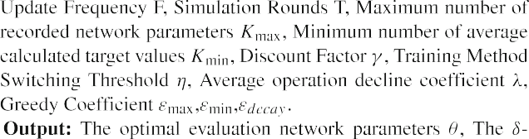
The traffic flow data from 09:00-10:00 and 17:30-18:30 on August 20, 2019 were selected for the experiment, corresponding to the flat-peak and peak traffic time periods of the simulation environment.
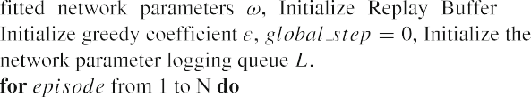
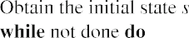
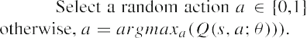
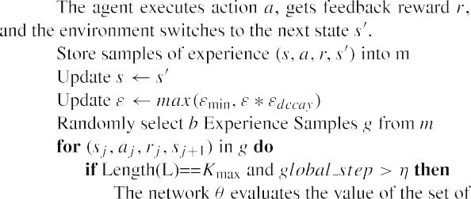
The number of phases of the original intersection is 4, and the phase details are shown in Fig. 4 The signal timing scheme period is 133s during the flat-peak periods, the first phase duration is 32s, the second phase duration is 32s, the third phase duration is 32s, and the fourth phase duration is 25s. The signal timing scheme period is 150s during the peak periods, the first phase duration is 33s, the second phase duration is 33s, the third phase duration is 34s, and
the fourth phase duration is 28s.
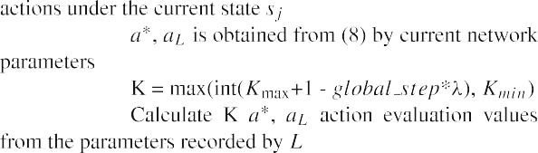
The 200m road segments before the stop line of the four incoming lanes at the intersection is taken as the monitoring object, the segmented discrete traffic state encoding unit length is 5m, and the simulation process is maintained for 30 minutes. The AWA-DDQN model in the signal control scenario obtains the real traffic flow information of the road approach through DTSE, defines whether to switch to the next phase as the agent action and constructs a real-time intelligent signal control scheme based on the change of the number of vehicles in the global queue and the average speed after taking action as the reward.
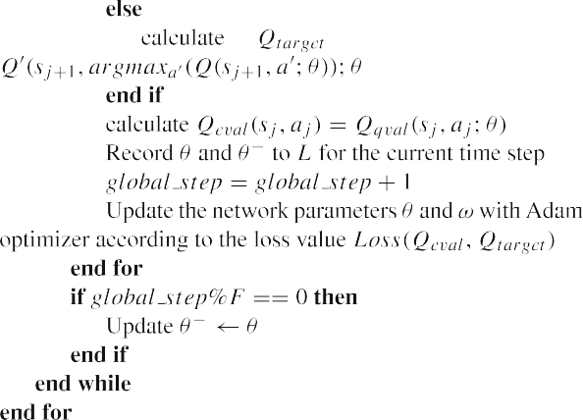
The intersection timing scheme corresponds to the time period of the road historical traffic flow as the model input, the simulation period traffic flow corresponding to the signal timing scheme as the model output, the traffic flow data is shown in Table 1.
In order to achieve a simulation of the traffic situation as real as possible, the experiment does not change the phase sequence of the original intersection. There is also a 3s yellow transition phase at the end of each green phase for clearing vehicles that have not yet exited the intersection. In this paper, the traffic data is set up according to the input requirements of the Vissim simulation software, while different types of sensors are set up in the road network profile for the purpose of obtaining real-time vehicle information through each lane.

Evaluation metrics

Algorithm 1 Traffic signal optimization control algorithm based on AWA-DDQN.
The AWA-DDQN model needs to obtain the average number of vehicles in the queue from the fixed timing scheme as the baseline when constructing the reward function, and the metrics used to verify the correctness and accuracy of the model in the experiment mainly include the average vehicle delay, the average queue length

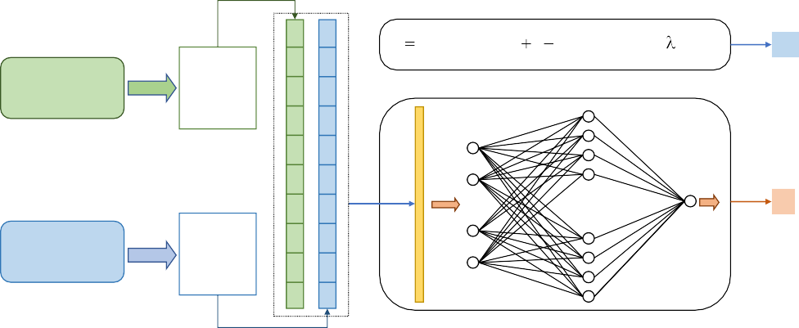
Fig. 6 AWA-DDQN
K max(int(K_{max} 1 global _ step * ), K_{min} )
K
Evaluation Network
evaluate Q1 (s ', a* )
ĂĂ
Q (s ', a* )
n
fold
δ
Target
Network
evaluate
Q (s ', a )
ˆ
1
*
ĂĂ
Qˆn (s ', a*)
superparametric calculation flow chart
……
……

and the average number of stops, which are defined as follows:
- Baseline of reward function: The average number of vehicles in queue is obtained by simulating the original
fixed time allocation scheme, as shown in (9).

- Average queue length: The average value of the length of vehicles that meet the queue speed for each lane at the complete simulation step, as shown in (11).
1 nlane
Σ
Queue average = Queue lane (11)
nlane
i

i=1

Queuing veh
nstep
= queueV ehicles
1 Σ
fixed
nstep
i
(9)
Where, n
lane
denotes the number of all incoming

i=1

Where, n_{step} denotes the number of times the queue vehicle information is obtained during the training process of a simulation round, and its value is equal to the total simulation time divided by the simulation step
lanes in the simulation environment, Queue lane_{i}
denotes the average queue length of lane i during the
whole simulation.
  - Average Number of Stops: The average value of the number of stops at the intersection for all observed vehicles before crossing the stop line, as shown in (12).

length. queueV ehicles_{i}
queued vehicles at the i-th time step.
- Average vehicle delay: The average of the difference
denotes the global number of
nveh
Stops average = Stops veh
1 Σ
nveh
i
(12)

i=1

between the actual travel time of all observed vehicles and the travel time without interference from other vehicles and without signal interception, as shown in (10).
Where, Stops veh_{i} denotes the number of stops of vehicle i at the intersection.

Experimental results and analysis

nveh
1 Σ
Delay average = Delay vehicle
nveh
i

(10)

Experimental parameters and environment settings

i=1
For the initial parameters setting of the AWA-DDQN

Where, n_{veh} denotes the number of all cars passing through the intersection during the training round of the simulation, and Delay vehicle_{i} denotes the delay time of vehicle i at the intersection.
algorithm, this study considers the stability of the model training process. The parameter settings are shown in Table 2. The initial stage of simulation will be preceded by the filling operation of the replay memory, and the training

Table 1 Intersection traffic flow data
Traffic Flow Data/Vehicle | from South to North | from East to West | from North to South | from West to East
flat-peak periods Turn Left | 306 | 130 | 206 | 164
Straight Ahead | 412 | 616 | 396 | 528
Turn Right | 162 | 188 | 178 | 214
peak periods Turn Left | 557 | 308 | 381 | 229
Straight Ahead | 639 | 1165 | 743 | 1206
Turn Right | 268 | 338 | 218 | 359

Table 2 Experimental parameter setting
Parameter | Value | Parameter | value
Replay Buffer Size | 10240 | State Matrix Size | [89,86]
Learning Rate | 0.001 | Action Size | 2
Batch Size | 128 | Number of Iterations | 400
Discount Factor | 0.99 | Simulation Cycle | 1800s
Update Frequency | 100 | Cell Length | 5m
Simulation Step | 5s | ratio | 2/3
greenmin | 10s | greenmax | 40s
λ | 0.01 | Greedy Factor | 0.9 → 0.01
Kmin, Kmax | 5, 10 | η | 1000
k1 , k1 | 0.2, 0.1 | k3 , k4 | 0.5, 1.5

data of this process were excluded from the final results of the experiment.
This paper is based on an Intel Core i7-12700F CPU, NVIDIA GeForce RTX 3070Ti 8GB hardware device, and Vissim4.30 traffic simulation software for experimental comparison. Vissim is a mature traffic simulation modeling tool, which is highly flexible, intuitive, and can generate detailed and accurate simulation results, and provides COM interfaces for various programming languages to control traffic signals and obtain various traffic information. Meanwhile, Tensorflow-gpu2.4.0, one of the most popular deep learning frameworks, is used to implement simulation experiments for optimal control of AWA-DDQN traffic signals based on single intersections.

Analysis of experimental results

In order to demonstrate the effectiveness of AWA-DDQN on the signal control, this paper conducts comparison experiments on the mainstream DQN series models with the same network structure and initial conditions. The model improvement effect can be analyzed by the metrics of average delay, the average queue length and the average number of stops of vehicles in the traffic simulation environment. The number of training rounds of the simulated experiments for comparison is 400, and the experimental results of the traffic flow in the flat-peak periods are shown in Fig. 7, and the experimental results of the traffic flow in the peak periods are shown in Fig. 8.
The experiments recorded the average vehicle delay, the average vehicle queue length, and the average number of vehicle stops for different models at each iteration round under the same traffic environment. The analysis of the distribution of the above data reveals that the DQN model is still in a state of oscillation at the late stage of training, and the result of poor convergence leads to poor performance
of signal control, and the agent is still unable to maintain high traffic efficiency at the late stage of iteration.DDQN and WA-DDQN have a more obvious convergence trend than DQN, and although there are individual samples with poor performance in the late stage of model training, the overall optimization effect is more stable, and both show similar control effects in single intersection signal control optimization. The comparison chart shows that although the signal control strategies of DDQN and WA-DDQN have more obvious optimization effects in the late training period, they still remain in the exploration results of the suboptimal strategies. Compared with the AWA-DDQN model proposed in this paper, DQN, DDQN and WA-DDQN all show obvious limitations. AWA-DDQN eventually has the most obvious optimization effect for the same number of iterations, and the model has explored significantly optimized control strategies after the 300th round of training and maintains a high frequency of superior strategies in the later stages of training.
The experimental results show that in the experiments on the flat-peak dataset, AWA-DDQN reduces 2.8% in the average delay evaluation metric, 3.0% in the average queue length evaluation metric, and 3.8% in the average number of stops evaluation metric compared with the suboptimal algorithm; in the peak data set, AWA-DDQN reduces 4.4% in the average delay evaluation metric, 5.8% in the average queue length evaluation metric, and 6.7% in the average number of stops evaluation metric compared with the suboptimal algorithm, which verifies that the model has a significant improvement effect in optimizing signal control.
In addition, the model still has high optimization efficiency under the worst control effect situation, which ensures the robustness of the agent and improves the safety of intelligent traffic control. AWA-DDQN model also shows excellent exploration effect in the optimal control, and achieves the optimal control effect that is not achieved by

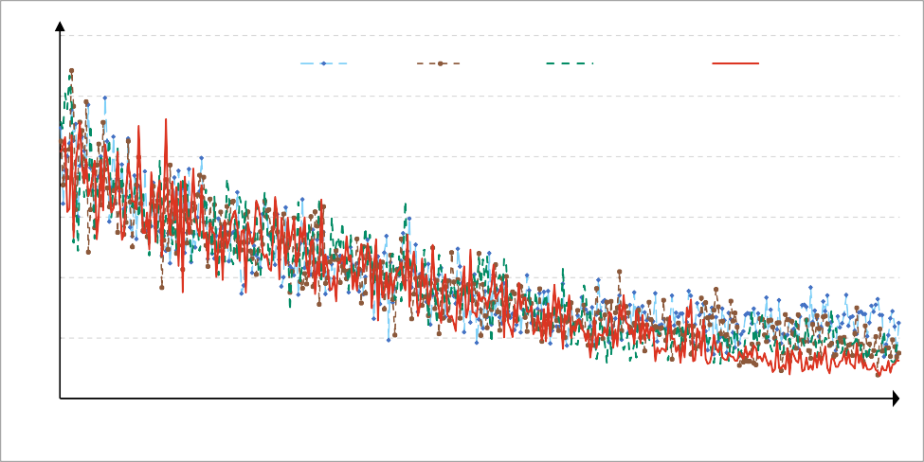
Fig. 7 Comparison chart of the results of experimental results under flat peak data set
28
DQN
DDQN
WA-DDQN
AWA-DDQN
26

24

22

20

18

16
1 16 31 46 61 76 91 106 121 136 151 166 181 196 211 226 241 256 271 286 301 316 331 346 361 376 391
Training Rounds
Average Delays/s

      - Average Vehicle Delay Comparison Chart under Flat Peak Tra c Flow

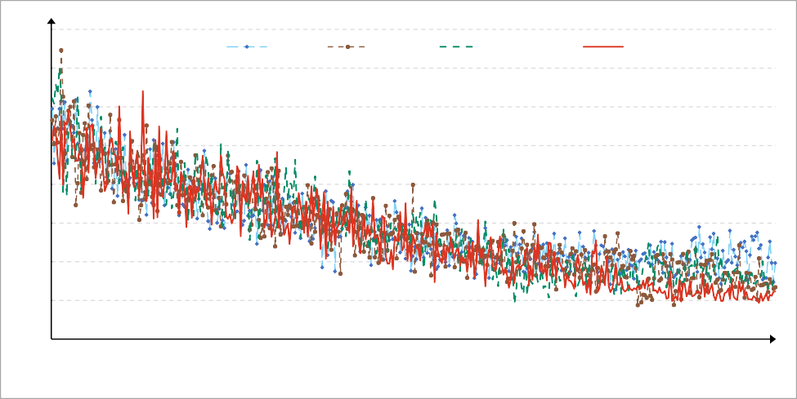
      - Average Vehicle Queue Length Comparison Chart under Flat Peak Tra c Flow
19

18
DQN
DDQN
WA-DDQN
AWA-DDQN
17

16

15

14

13

12

11
1 16 31 46 61 76 91 106 121 136 151 166 181 196 211 226 241 256 271 286 301 316 331 346 361 376 391
Training Rounds
Queue Length/m

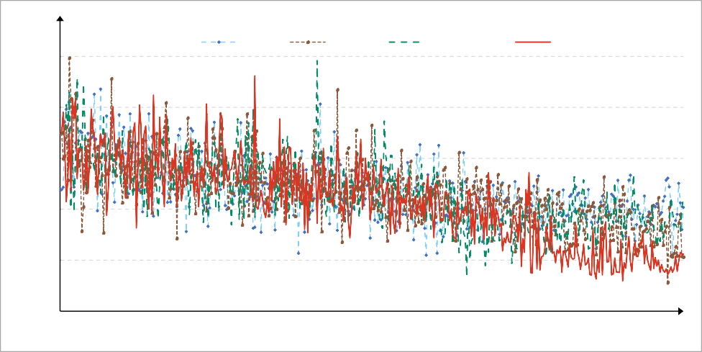
      - Average Vehicle Number of Stops Comparison Chart under Flat Peak Tra c Flow
0.95
DQN
DDQN
WA-DDQN
AWA-DDQN
0.9

0.85

0.8

0.75

0.7
1 16 31 46 61 76 91 106 121 136 151 166 181 196 211 226 241 256 271 286 301 316 331 346 361 376 391
Trainning Rounds
Number of Stops

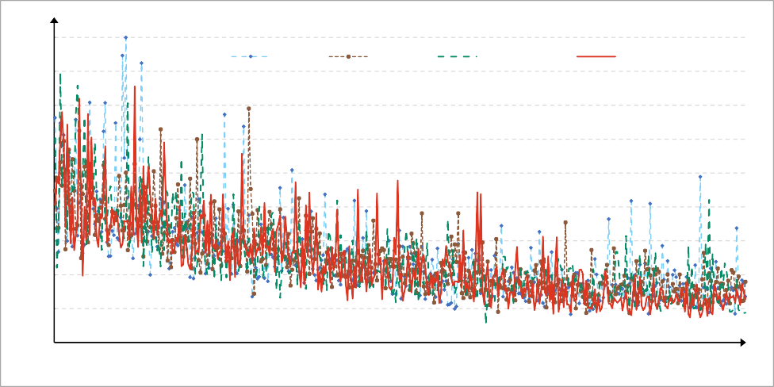
- Average Vehicle Delay Comparison Chart under Peak Tra c Flow
65

60
55
50

45
40
35
30
25
20
DQN
DDQN
WA-DDQN
AWA-DDQN
1 16 31 46 61 76 91 106 121 136 151 166 181 196 211 226 241 256 271 286 301 316 331 346 361 376 391
Training Rounds
Queue Length/m
Average Delays/s

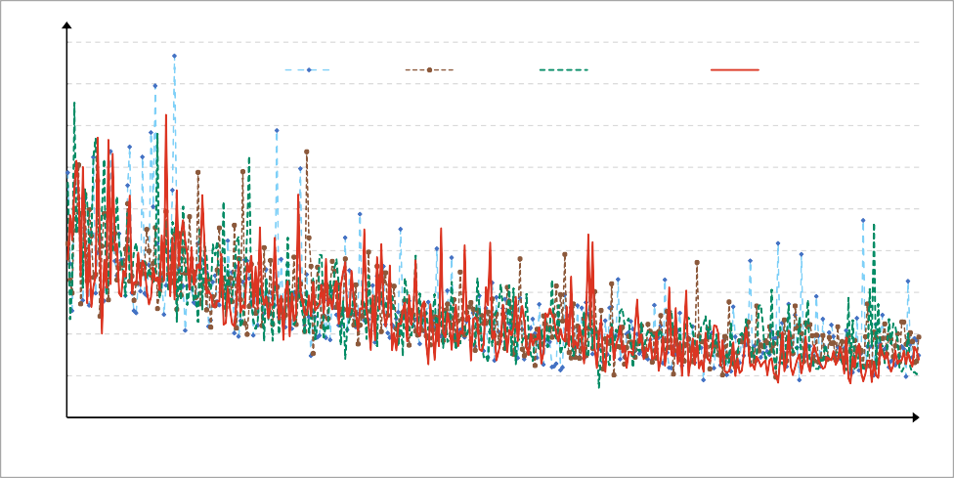
- Average Vehicle Queue Length Comparison Chart under Peak Tra c Flow
63
58
53
48
43
38
33
28
23
18
DQN
DDQN
WA-DDQN
AWA-DDQN
1 16 31 46 61 76 91 106 121 136 151 166 181 196 211 226 241 256 271 286 301 316 331 346 361 376 391
Training Rounds
Number of Stops

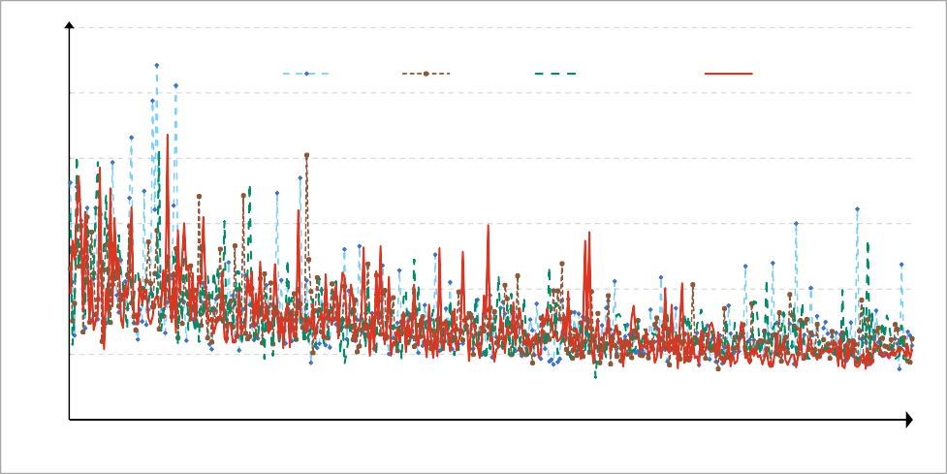
- Average Vehicle Number of Stops Comparison Chart under Peak Tra c Flow
3.6

3.1
DQN
DDQN
WA-DDQN
AWA-DDQN
2.6

2.1

1.6

1.1

0.6
1 16 31 46 61 76 91 106 121 136 151 166 181 196 211 226 241 256 271 286 301 316 331 346 361 376 391
Training Rounds
Fig. 8 Comparison chart of the results of experimental results under peak data set

Table 3 Analysis table of experimental results based on flat peak traffic dataset

Evaluation Indicators |  | DQN | DDQN | WA-DDQN | AWA-DDQN | Fixed Timing
Delay Average | Average Value | 18.50s | 18.01s | 17.83s | 17.32s | 39.60s
 | Best Value | 17.38s | 16.78s | 17.15s | 16.76s
 | Worst Value | 19.68s | 19.61s | 18.96s | 19.27s
Queue Length | Average Value | 13.09m | 12.66m | 12.70m | 12.28m | 26.54m
 | Best Value | 12.28m | 11.88m | 12.14m | 11.93m
 | Worst Value | 13.90m | 13.74m | 13.70m | 13.56m
Number of Stops | Average Value | 0.80 | 0.78 | 0.79 | 0.75 | 1.08
 | Best Value | 0.75 | 0.73 | 0.75 | 0.73
 | Worst Value | 0.83 | 0.83 | 0.83 | 0.84

the comparison algorithms. 100 rounds of results analysis after flat-peak data and peak data experiments are shown in Tables 3 and 4.
The experimental results demonstrate that both DQN and its improved models DDQN, WA-DDQN and other deep reinforcement learning based signal control strategies have significant optimization effects compared to the original fixed timing scheme. And the signal control strategy based on AWA-DDQN shows more obvious optimization effect in comparing algorithms, and the analysis of experimental results shown by bar chart is shown in Figs. 9 and10.
The above graphs show that the AWA-DDQN model studied in this paper shows a superior control effect, which provides better training data for the neural network of the agent by means of the average estimates of adjacent time steps and adaptive parameters for training. Therefore, the AWA-DDQN agent can master the optimal signal control strategy to effectively improve the road traffic efficiency, reduce the vehicle travel time and alleviate traffic congestion.

Trade-offs of traffic signal control method based on AWA-DDQN

Our proposed traffic signal optimal control algorithm based on AWA-DDQN needs to improve the efficiency of model processing data while guaranteeing the optimization effect of the algorithm, and provide a guarantee of higher reliability for the large-scale application of the algorithm in the future. However, the traffic signal optimal control algorithm based on AWA-DDQN needs extra memory space to record the network training parameters of adjacent time steps, and the action values need to be calculated through the network parameters when performing the target value calculation. Calculating the weights and averages of the two network evaluation values through the above calculation results then increases the cost of network model training to some extent.
Although the current cost of hardware equipment and data processing technology have been able to handle the computational task of the algorithm in our single

Table 4 Analysis table of experimental results based on peak traffic dataset

Evaluation Indicators |  | DQN | DDQN | WA-DDQN | AWA-DDQN | Fixed Timing
Delay Average | Average Value | 28.45s | 28.20s | 27.64s | 26.40s | 63.97s
 | Best Value | 24.22s | 24.33s | 24.35s | 23.70s
 | Worst Value | 44.43s | 33.91s | 41.04s | 30.76s
Queue Length | Average Value | 26.87m | 26.79m | 26.41m | 24.89m | 56.50m
 | Best Value | 22.51m | 22.84m | 23.20m | 22.10m
 | Worst Value | 41.64m | 31.88m | 41.36m | 29.04m
Number of Stops | Average Value | 1.23 | 1.19 | 1.20 | 1.11 | 2.30
 | Best Value | 0.99 | 0.99 | 1.06 | 0.99
 | Worst Value | 2.21 | 1.56 | 1.98 | 1.35

Fig. 9 Comparison bar chart of the results of experimental results under flat peak data set
20
DQN DDQN WA-DDQN AWA-DDQN
19

18

17

16

15
Average
Best Evaluation Index
Worst
Average Delays/s

      - Bar Chart of Average Vehicle Delay Comparison under Flat Peak Tra c Flow

      - Bar Chart of Average Vehicle Queue Length Comparison under Flat Peak Tra c Flow
14.5

14
DQN DDQN WA-DDQN AWA-DDQN
13.5

13

12.5

12

11.5

11

10.5
Average
Best
Evaluation Index
Worst
Queue Length/m

      - Bar Chart of Average Vehicle Number of Stops Comparison under Flat Peak Tra c Flow
0.86
0.84
0.82
0.8
0.78
0.76
0.74
0.72
0.7
0.68
0.66
DQN DDQN WA-DDQN AWA-DDQN
Average
Best
Evaluation Index
Worst
Number of Stops

intersection scenario with relative ease, the complex structure of the urban road network brings about the concurrent computational volume of multiple intersections, which is still a key optimization problem for regional
signal control. Urban traffic signal control as a key issue concerning road traffic safety and traffic efficiency, the response speed of signal decision affects the accuracy and safety of phase switching action. How to improve the

- Bar Chart of Average Vehicle Delay Comparison under Peak Tra c Flow
50

45
DQN DDQN WA-DDQN AWA-DDQN
40

35

30

25

20

15
Average
Best Evaluation Index
Worst
Average Delays/s

- Bar Chart of Average Vehicle Queue Length Comparison under Peak Tra c Flow
45

40
DQN DDQN WA-DDQN AWA-DDQN
35

30

25

20

15
Average
Best
Evaluation Index
Worst
Queue Length/m

- Bar Chart of Average Vehicle Number of Stops Comparison under Peak Tra c Flow
2.5
2
DQN DDQN WA-DDQN AWA-DDQN
1.5
1
0.5
0
Average
Best
Evaluation Index
Worst
Number of Stops
Fig. 10 Comparison bar chart of the results of experimental results under peak data set

accuracy and speed in image information extraction, traffic flow state input, neural network fitting, and agent decision making is a topic that needs further research based on the algorithm and deep reinforcement learning proposed in this paper to be practically applied to traffic signal control.

Conclusions and prospects
With the application of deep reinforcement learning to traffic signal control becoming a research hotspot, various research results have shown obvious enhancement effects on the application of signal control. However, the existing signal control algorithms have their own defects, which to a certain extent restrict the optimization effect of intelligent control algorithms in traffic scenarios. This paper proposes a deep reinforcement learning model AWA-DDQN based on an Adaptive Weighted Averaged Double Deep Q Network to improve the optimization capability of single intersection signal control. In order to improve the accuracy of the model for action-value evaluation, the target value calculation is carried out through the setting of adaptive parameters; in order to improve the adaptivity of the model for different environments, the queued vehicles with fixed allocation time are considered as the measurement factor of the reward function. Experiments have proved the optimal control effect of AWA-DDQN compared with other DQN series mainstream algorithms.
However, realistic traffic control scenarios with multiple intersections are interconnected, and the traffic flows between adjacent intersections have a strong correlation. In this paper, we only consider the control method of single intersection signals for the time being, and the next work will focus on further considering the cooperation and communication among multi-agents. In addition, ensuring that the model is effective at different intersections in the region while reducing the computational complexity of the overall algorithm is also an urgent issue to be addressed in future work.
Acknowledgments This work was supported by the Fujian Province Science and Technology Plan under Grant no. 2020H0016, National Natural Science Foundation of China under Grant no. 61802133.
Data Availability The data used to support the findings of this study have not been made available because of relevant regulations of traffic information management.

Declarations
Conflict of Interests The authors declare that there is no conflict of interest regarding the publication of this paper.

References

- Yu C, Feng Y, Liu HX, Ma W, Yang X (2018) Integrated optimization of traffic signals and vehicle trajectories at iso-lated urban intersections. Transp Res B Methodol 112:89–112. https://doi.org/10.1016/j.trb.2018.04.007
- Yau K-LA, Qadir J, Khoo HL, Ling MH, Komisarczuk P (2017) A survey on reinforcement learning models and algorithms for traffic signal control. ACM Comput Surveys (CSUR) 50(3):1–38. https://doi.org/10.1145/3068287
- Mnih V, Kavukcuoglu K, Silver D, Rusu AA, Veness J, Bellemare MG, Graves A, Riedmiller M, Fidjeland AK, Ostrovski G et al (2015) Human-level control through deep reinforcement learning. Nature 518(7540):529–533. https://doi.org/10.1038/nature14236
- Wu D, Dong X, Shen J, Hoi SC (2020) Reducing estima-tion bias via triplet-average deep deterministic policy gradi-ent. IEEE Trans Neural Netw Learn Syst 31(11):4933–4945. https://doi.org/10.1109/TNNLS.2019.2959129
- Van Hasselt H, Guez A, Silver D (2016) Deep reinforcement learning with double q-learning. In: Proceedings of the AAAI Conference on Artificial Intelligence. AAAI, vol 30, pp 2094–2100. https://doi.org/10.1609/aaai.v30i1.10295
- Abliz P, Ying S (2022) Underestimation estimators to q-learning. Inf Sci 607:173–185. https://doi.org/10.1016/j.ins.2022.05.090
- Anschel O, Baram N, Shimkin N (2017) Averaged-dqn: variance reduction and stabilization for deep reinforcement learning. In: Proceedings of the 34th international conference on machine learning. Proceedings of machine learning research. PMLR, vol 70, pp 176–185
- Zhang Z, Pan Z, Kochenderfer MJ (2017) Weighted double q-learning. In: Proceedings of the 26th international joint conference on artificial intelligence. IJCAI, pp 3455–3461. https://doi.org/10.24963/ijcai.2017/483
- Jinjin W, Quan L, Song C, Yan Y (2020) Averaged weighted dou-ble deep q-network. J Comput Res Dev (in Chinese) 57(3):576–
589. https://doi.org/10.7544/issn1000-1239.2020.20190159
- Joo H, Ahmed SH, Lim Y (2020) Traffic signal control for smart cities using reinforcement learning. Comput Commun 154:324–
330. https://doi.org/10.1016/j.comcom.2020.03.005
- Zhang Y, Zhou Y, Lu H, Fujita H (2020) Traffic network flow prediction using parallel training for deep convolutional neural networks on spark cloud. IEEE Trans Indust Inf 16(12):7369–7380. https://doi.org/10.1109/TII.2020.2976053
- Li L, Lv Y, Wang F-Y (2016) Traffic signal timing via deep reinforcement learning. IEEE/CAA J Automatica Sinica 3(3):247–254. https://doi.org/10.1109/JAS.2016.7508798
- Wei H, Zheng G, Yao H, Li Z (2018) Intellilight: a reinforce-ment learning approach for intelligent traffic light control. In: Proceedings of the 24th ACM SIGKDD international conference on knowledge discovery & data mining. ACM, pp 2496–2505. https://doi.org/10.1145/3219819.3220096
- Xu M, Wu J, Huang L, Zhou R, Wang T, Hu D (2020) Network-wide traffic signal control based on the discovery of critical nodes and deep reinforcement learning. J Intell Transp Syst 24(1):1–10. https://doi.org/10.1080/15472450.2018.1527694
- Zang X, Yao H, Zheng G, Xu N, Xu K, Li Z (2020) Metalight: Value-based meta-reinforcement learning for traffic signal control. In: Proceedings of the AAAI conference on artificial intelligence. AAAI, vol 34, pp 1153–1160. https://doi.org/10.1609/aaai.v34i01.
5467
- Liang X, Du X, Wang G, Han Z (2019) A deep reinforcement learning network for traffic light cycle control. IEEE Trans Veh

Technol 68(2):1243–1253. https://doi.org/10.1109/TVT.2018.
2890726
- Naeem F, Seifollahi S, Zhou Z, Tariq M (2020) A gen-erative adversarial network enabled deep distributional rein-forcement learning for transmission scheduling in internet of vehicles. IEEE Trans Intell Transp Syst 22(7):4550–4559. https://doi.org/10.1109/TITS.2020.3033577
- Xi L, Wu J, Xu Y, Sun H (2020) Automatic generation control based on multiple neural networks with actor-critic strategy. IEEE Trans Neural Netw Learn Syst 32(6):2483–2493. https://doi.org/10.1109/TNNLS.2020.3006080
- Han G, Zheng Q, Liao L, Tang P, Li Z, Zhu Y (2022) Deep reinforcement learning for intersection signal con-trol considering pedestrian behavior. Electronics 11(21):3519. https://doi.org/10.3390/electronics11213519
- Wang Y, Li X, Wan P, Chang L, Deng X (2022) Dueling deep q-networks for social awareness-aided spectrum sharing. Comp Intell Syst 8(3):1975–1986. https://doi.org/10.1007/s40747-021-00382-1
- Long M, Zou X, Zhou Y, Chung E (2022) Deep rein-forcement learning for transit signal priority in a connected environment. Trans Res Part C: Emerg Technol 142:103814. https://doi.org/10.1016/j.trc.2022.103814
- Zhi L, Shipeng C, Yang S, Xi Y (2020) Signal control of single intersection based on improved deep reinforcement learning method. Comput Sci (in Chinese) 47(12):226–232. https://doi.org/10.11896/jsjkx.200300021
- Yoon J, Ahn K, Park J, Yeo H (2021) Transferable traffic signal control: reinforcement learning with graph centric state representation. Transp Res Part C: Emerg Technol 130:103321. https://doi.org/10.1016/j.trc.2021.103321
- Wang H, Yuan Y, Yang XT, Zhao T, Liu Y (2021) Deep q learning-based traffic signal control algorithms: model develop-ment and evaluation with field data. J Intell Transp Syst:1–21. https://doi.org/10.1080/15472450.2021.2023016
- Zhu R, Wu S, Li L, Lv P, Xu M (2022) Context-aware multi-agent broad reinforcement learning for mixed pedestrian-vehicle adaptive traffic light control. IEEE Internet Things J 9(20):19694–19705. https://doi.org/10.1109/JIOT.2022.3167029
- Zhao W, Ye Y, Ding J, Wang T, Wei T, Chen M (2022) Ipdalight: intensity-and phase duration-aware traffic signal control based on reinforcement learning. J Syst Archit 123:102374. https://doi.org/10.1016/j.sysarc.2021.102374
- Shabestary SMA, Abdulhai B (2022) Adaptive traffic signal control with deep reinforcement learning and high dimen-sional sensory inputs: case study and comprehensive sensitivity analyses. IEEE Trans Intell Transp Syst 23(11):20021–20035. https://doi.org/10.1109/TITS.2022.3179893
- Zhang Y, Zhou Y, Lu H, Fujita H (2021) Cooperative multi-agent actor–critic control of traffic network flow based on edge computing. Futur Gener Comput Syst 123:128–141. https://doi.org/10.1016/j.future.2021.04.018
- Wu Q, Wu J, Shen J, Du B, Telikani A, Fahmideh M, Liang C (2022) Distributed agent-based deep reinforcement learning for large scale traffic signal control. Knowl-Based Syst 241:108304. https://doi.org/10.1016/j.knosys.2022.108304
- Ma D, Zhou B, Song X, Dai H (2022) A deep reinforcement learning approach to traffic signal control with temporal traffic pattern mining. IEEE Trans Intell Transp Syst 23(8):11789–11800. https://doi.org/10.1109/TITS.2021.3107258
- Alegre LN, Ziemke T, Bazzan AL (2022) Using reinforce-ment learning to control traffic signals in a real-world scenario: an approach based on linear function approxi-
mation. IEEE Trans Intell Transp Syst 23(7):9126–9135. https://doi.org/10.1109/TITS.2021.3091014
- Wan C-H, Hwang M-C (2018) Value-based deep reinforcement learning for adaptive isolated intersection signal control. IET Intell Transp Syst 12(9):1005–1010. https://doi.org/10.1049/iet-its. 2018.5170
- Zhang R, Ishikawa A, Wang W, Striner B, Tonguz OK (2020) Using reinforcement learning with partial vehicle detection for intelligent traffic signal control. IEEE Trans Intell Transp Syst 22(1):404–415. https://doi.org/10.1109/TITS.2019.2958859
- Liu B, Ding Z (2022) A distributed deep reinforcement learning method for traffic light control. Neurocomputing 490:390–399. https://doi.org/10.1016/j.neucom.2021.11.106
- Kamal MAS, Hayakawa T, Imura J-I (2019) Development and evaluation of an adaptive traffic signal control scheme under a mixed-automated traffic scenario. IEEE Trans Intell Transp Syst 21(2):590–602. https://doi.org/10.1109/TITS.2019.2896943
- Li J, Shi X, Li J, Zhang X, Wang J (2020) Random curiosity-driven exploration in deep reinforcement learning. Neurocomputing 418:139–147. https://doi.org/10.1016/j.neucom.2020.08.024
- Jamil ARM, Ganguly KK, Nower N (2020) Adaptive traffic signal control system using composite reward architecture based deep reinforcement learning. IET Intell Transp Syst 14(14):2030–2041. https://doi.org/10.1049/iet-its.2020.0443
- Noaeen M, Naik A, Goodman L, Crebo J, Abrar T, Abad ZSH, Bazzan AL, Far B (2022) Reinforcement learning in urban net-work traffic signal control: a systematic literature review. Expert Syst Appl 199:116830. https://doi.org/10.1016/j.eswa.2022. 116830
- Lee J, Chung J, Sohn K (2019) Reinforcement learning for joint control of traffic signals in a transportation network. IEEE Trans Veh Technol 69(2):1375–1387. https://doi.org/10.1109/TVT. 2019.2962514
- Icarte RT, Klassen TQ, Valenzano R, McIlraith SA (2022) Reward machines: exploiting reward function structure in reinforcement learning. J Artif Intell Res 73:173–208. https://doi.org/10.1613/ jair.1.12440
- Wen Y, Su Q, Shen M, Xiao N (2022) Improving the exploration efficiency of dqns via the confidence bound methods. Appl Intell 52(13):15447–15461. https://doi.org/10.1007/s10489-022-
03363-0
- Lv P, Wang X, Cheng Y, Duan Z, Chen CP (2020) Integrated dou-ble estimator architecture for reinforcement learning. IEEE Trans Cybern 52(5):3111–3122. https://doi.org/10.1109/TCYB.2020.
3023033
- Du Y, ShangGuan W, Chai L (2021) A coupled vehicle-signal control method at signalized intersections in mixed traffic environment. IEEE Trans Veh Technol 70(3):2089–2100. https://doi.org/10.1109/TVT.2021.3056457
- Zheng Y, Hao J-Y, Zhang Z-Z, Meng Z-P, Hao X-T (2020) Effi-cient multiagent policy optimization based on weighted estimators in stochastic cooperative environments. J Comput Sci Technol 35(2):268–280. https://doi.org/10.1007/s11390-020-9967-6

Publisher’s note Springer Nature remains neutral with regard to jurisdictional claims in published maps and institutional affiliations.
Springer Nature or its licensor (e.g. a society or other partner) holds exclusive rights to this article under a publishing agreement with the author(s) or other rightsholder(s); author self-archiving of the accepted manuscript version of this article is solely governed by the terms of such publishing agreement and applicable law.



Youqing Chen was born in Quanzhou, China, in 1997. He received his bachelor’s degree in software engineering from Huaqiao University in Xiamen, China in 2016.
He is currently studying for a master’s degree in the School of Computer Science and Technology, Huaqiao Uni-versity. His current research interest is reinforcement learn-ing, deep learning, and intelli-gent transportation systems.
Ming Ye was born in Quanzhou, China, in 1998. He received his bachelor’s degree in networking engineering from Inner Mongolia Minzu University in 2016. He is currently studying for a mas-ter’s degree in the School of Computer Science and Tech-nology, Huaqiao University. His current research interest is deep reinforcement learning, neural network, and vehicle routing problem.


Huizhen Zhang was born in Longyan, China, in 1983. He received the B.S. degree in computer science and the Ph.D. degree in computer architecture from the Univer-sity of Science and Technol-ogy of China in 2005 and 2010, respectively.
He is currently an Asso-ciate Professor with the School of Computer Science and Technology, Huaqiao University in Xiamen. He has published more than ten research papers in interna-
tional journals and conference proceedings. His research mainly focuses on computer architecture, machine learning and intelligent transportation systems.


Minglei Liu was born in Wei-hai, China, in 1997. She received her bachelor’s degree in information management and information system from Shandong University of Sci-ence and Technology in Qing-dao, China in 2015. She is currently studying for a mas-ter’s degree in the School of Computer Science and Tech-nology, Huaqiao University. Her current research interest is reinforcement learning, deep learning, bus priority strategy.
Hui Xie was born in Fuzhou, China, in 1999. He received his bachelor’s degree in Inter-net of things project from Concord University College Fujian Normal University in Fuzhou, China in 2017.

He is currently studying for a master’s degree in the School of Computer Science and Technology, Huaqiao Uni-versity. His current research interest is reinforcement learn-ing, regional division, and traf-fic big data.


Yubiao Pan was born in Longyan, Fujian province, China in 1987. He received the B.S. and Ph.D. degree from the School of Computer Science and Technology, University of Science and Technology of China, Hefei, China, in 2010 and 2015, respectively.
He is currently a lecturer with the School of Com-puter Science and Technology, Huaqiao University in Xia-men. He is also a researcher with Xiamen Key Laboratory
of Data Security and Blockchain Technology. He has published more than 10 research papers in international journals and conference pro-ceedings. His current research interests include solid-state devices, distributed storage system, and data deduplication.

